**National Aboriginal Day Serving Up Tradition**

Jane Boehr  
Nipawin Journal  
Tuesday, June 23, 2015 10:25:16 MDT AM   
<http://www.nipawinjournal.com/2015/06/23/national-aboriginal-day-serving-up-tradition>

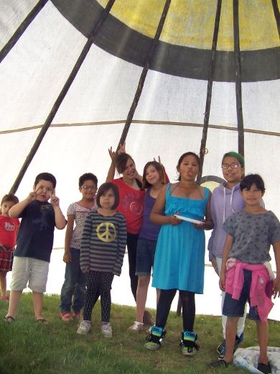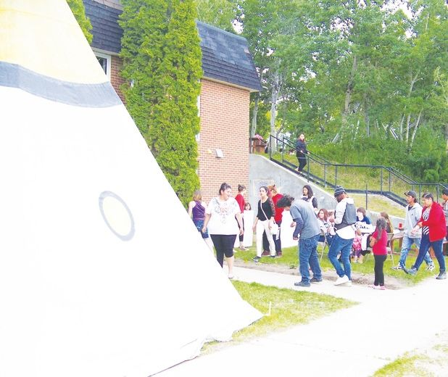

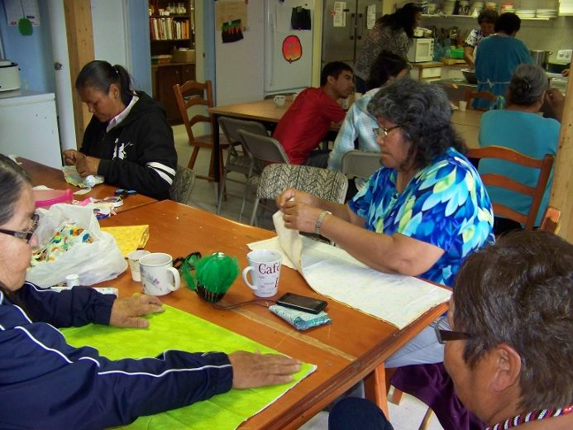 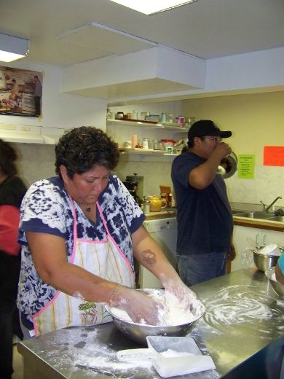

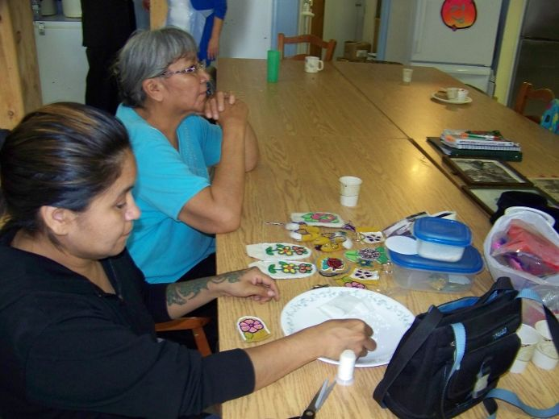

The Oasis Centre was a buzz with activity on National Aboriginal Day. Children were gathered for a hotdog and bannock lunch in a teepee set up in the front yard, while parents sat and watched as they sipped their Tim Horton's coffee. Women were gathered indoors making clothing for infants such as dresses, bonnets and laundry sachets. There were other young people doing detailed beadwork, each with his or her own task. The fine beads strung together made up beautiful images of flowers. Over in the kitchen several young women were elbow deep in white flour as they prepared the Bannock, which is a traditional Aboriginal bread of sorts.

Annette Nawakayas and her friend Hilda Roberts were busy working away in the kitchen at the Oasis Centre. They each had large metal mixing bowls full of flour and baking powder. The combination wasn’t precise but each lady knew how much was needed for the recipe.

With the flour up to the rim they mixed the bannock by hand. Roberts asked if we noticed there were no measuring cups. Here, the recipe and amount of each ingredient goes by feel and texture, more flour if it’s too sticky, more water and oil when the mixture is too dry.

Roberts prepares a well in the middle of the flour mixture for water and oil. This is done in order to combine the two wet ingredients at the same time. It’s almost like making bread.

“You can fry it or bake it”, says Roberts, “We made some Indian cake [too]. I make it at home alot. Everybody I know [makes it], my sister, my mother and Rita makes it”.

Roberts says her kids have learned how to make it too. Just one way to pass on the traditions of her heritage.

Over 50 people were present for the National Aboriginal Day activities. Several dozen had the chance to taste the freshly made bannock. This annual event helps mark the presence of the Aboriginal people in the community and in the outlying areas. But it serves as a purpose in order to share the heritage, the culture, the language and the ways of the First peoples.

What was said in the last encounter with the Oasis Centre was echoed here on National Aboriginal Day. It’s a chance to share a bit of history together. To meet and to be in fellowship with all the many cultures represented in the community.

Recipe for Bannock (any flour can be used):

Bannock may have originated in Scotland but some say it was invented by the Inuit. Historically bannock was made at the changing of the Gaelic seasons in Scotland. Some versions of bannock, Selkirk bannock for example, include large quantity of raisins. This type of Bannock is named after the town along the Scottish border where it's made. Indigenous North Americans also made known "frybread" or Indian bread. It has been found in cuisine of the Inuit, First Nations of Canada, Native Americans in the United States and in the cuisine of [Métis](https://en.wikipedia.org/wiki/M%C3%A9tis).

- 2 cups (500 mL) all-purpose flour

- 1 tbsp (15 mL) baking powder

- 1/2 tsp (2 mL) salt (use as needed no salt was used in the above story)

- 1/2 cup (125 mL) milk

- 1/2 cup (125 mL) water

- vegetable oil, for frying (in the above story oil was used along with the water mixture)

In large bowl, combine flour, baking powder and salt. Make a well in centre; pour in milk & water. Combine and knead doughy mixture by hand.

Turn out onto floured surface; with floured hands, press into 8-inch (20 cm) circle.  
Line a cookie sheet with parchment paper and bake in the oven at 350 until the dough rises, in the final stage turn on the broil function in order to get the top of the bannock slightly crispy.

To prepare on the stove use a cast-iron skillet well oiled with approx. 1 cm of oil; heat over medium heat. Fry dough, turning once, until puffed and golden, and tip of knife inserted in centre comes out clean, about 8 minutes.   
  
To serve, cut into 10 pieces. Triangular pieces cut from a round bannock are sometimes called scones.